Practical - 7

Practical Title: PHP Form Processing with Server-Side Validation and CSV/JSON File Storage
Problem Definition: Process submitted registration/contact form data using PHP. Validate and sanitize inputs on the server side and store records in CSV or JSON file format. Display success/error messages.

Theory :

Is the form submitted using POST?
Yes. The form should use the POST method so that the submitted registration or contact data is sent to the PHP server for processing. PHP can access the submitted values using POST after the form is submitted.

Are inputs validated and sanitized server side?
Yes. Server-side validation checks whether the submitted values are present and follow the required format, such as a valid email address or non-empty name. Sanitization removes or encodes unwanted characters before the data is displayed or stored. Server-side checks are important because browser-side validation can be bypassed.

Is file writing handled safely?
Yes. File writing should be handled carefully by checking the data before storing it, using appropriate file functions, and opening the file with the required mode. For CSV storage, fputcsv() can be used to write fields safely.

Are success and error responses displayed clearly?
Yes. After processing the form, PHP should display a clear success message when the data is validated and stored successfully. If validation or file storage fails, an understandable error message should be displayed so the user knows what needs to be corrected.

Implementation/ Output/ Result

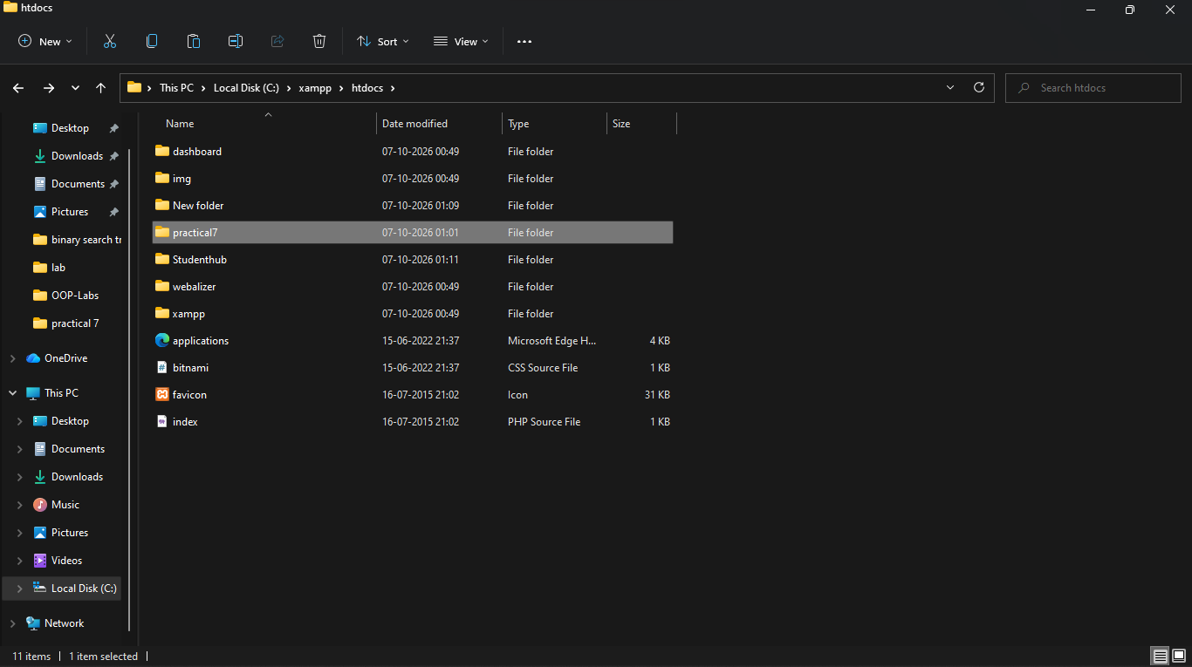
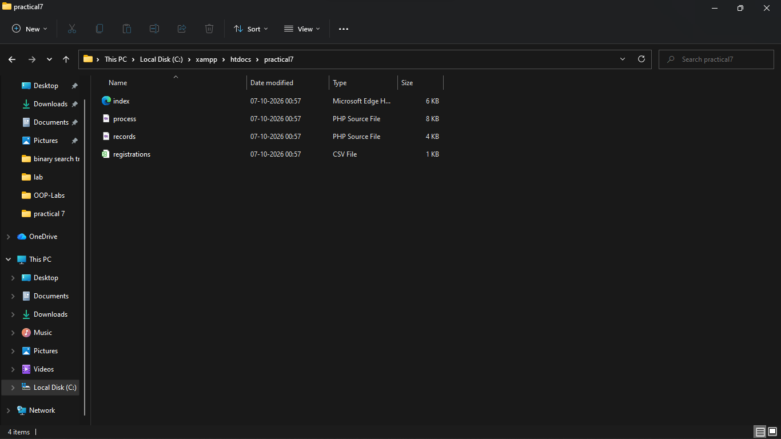

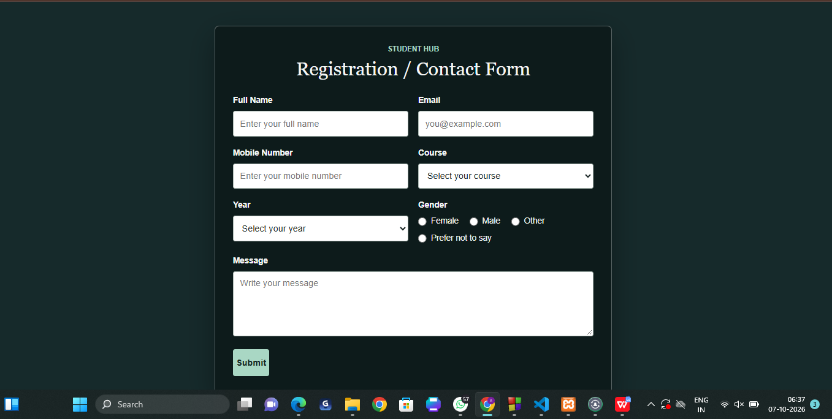

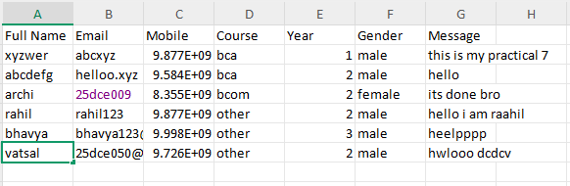

Learning Outcomes:
- Understand PHP form processing using POST requests.
- Implement server-side validation and sanitization of form inputs.
- Store submitted records using CSV or JSON file storage.
- Handle file writing safely in a small data collection system.
- Display clear success and error responses to users.
- Understand the basic workflow of a server-side form processor.

Dataset / Test Data:
- Registration/contact form inputs.
- Valid and invalid form submissions for testing.
- Generated CSV or JSON file containing stored records.

Tools / Technology Used:
- PHP
- XAMPP / WAMP / LAMP
- HTML5
- Browser Developer Tools

Post Laboratory Work:
Submit PHP source code, test cases, and the generated CSV/JSON file.

Advanced / Intermediate Extension:
- Intermediate: Display stored CSV/JSON records on a webpage.
- Advanced: Add CSRF token validation for form submission.

Viva Preparation:
- Explain the difference between GET and POST and why POST is used for form

submission.
- Explain server-side validation and why it is required even when HTML validation is present.
- Explain the purpose of sanitization in PHP.
- Explain how fputcsv() can be used for CSV file storage.
- Explain how json_encode() and file writing can be used for JSON storage.
- Explain how success and error messages are returned after form processing.
- Explain the purpose of CSRF token validation.

